**Tableau Insight: uncovering the voices of the digital age: social media analysis**

This section would outline the approach and methods that will be used to conduct social media analytics using Tableau. It would discuss how data will be collected from various socia media platforms, the tools and techniques for data cleaning and preprocessing, and the specific analyses and visualizations that will be performed in Tableau. This paragraph may also touch on any relevant data privacy and ethical considerations

**1 Brand Monitoring and Reputation Management:**

Scenario: A multinational corporation wants to monitor its brand reputation across various social media platforms.

Application: Using Tableau, the company can create real-time dashboards that track brand mentions, sentiment analysis, and key metrics such as engagement levels and reach.

Benefits: By analyzing social media data, the company can quickly identify emerging issues, respond to customer feedback, and proactively manage its brand reputation. Scenarios A marketing agency is running a social media campaign for a client and wants to measure its effective

**2. Marketing Campaign Analysis and Optimization:**

Scenario: A marketing agency is running a social media campaign for a client and wants to measure its effectiveness.

Application: With Tableau, the agency can visualize campaign performance metrics such as click-through rates, conversion rates, and audience demographics.

Benefits: By analyzing campaign data in real-time, the agency can identify which channels and messages are most effective, allocate resources accordingly, and optimize the campaign for better results.

**3. Customer Insights and Personalization:**

Scenario: An e-commerce company wants to better understand its customers' preferences and behaviors on social media.

Application: Using Tableau, the company can analyze social media data to identify winds, preferences, and purchase patterns among its target audience.

Benefits: By gaining insights from social media analytics, the company can tallonits marketing efforts, personalize product recommendations, and improve the overall custome experience, leading to increased saled customer loyalty.

**Technical Architecture:**

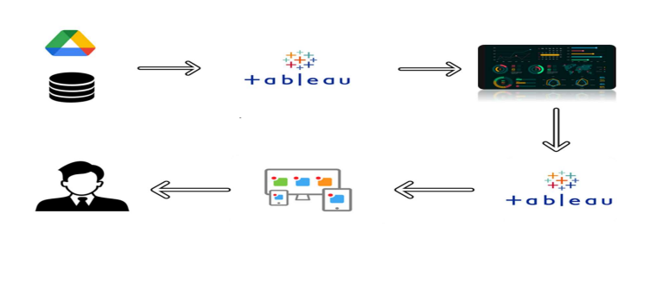

**Project Flow**

To accomplish this, we have to complete all the activities listed below,

* Data collection
  + Collect the dataset or create the dataset
* Database /Spread sheet Connection
  + Collect data will be stored into the database or upload into google drive
  + Connect the tableau desktop with google drive option or required database under connectors
* Visualizing and analysing data
* Understand the Data and the Business Questions
* Based on the Business questions try to develop the visualizations
* Develop the Dashboard
* Develop the Story board
* Publishing to the Tableau public
  + Developed Visualizations, Dashboard and story will be published to Tableau public Account.
  + Once it is published, we will get the shareable links
* Web Application Integration
  + Develop a web application using HTML, CSS or Using Bootstrap
  + Integrate the Visualizations, Dashboard and Story with the Web Application

Milestone 1: Data Collection & Extraction from Database

Data collection and extraction from a database involve gathering information stored within the database for analysis or utilization. And retrieving relevant data for analysis or use.

* Understand the data

The In Dataset Twitter.csv data contains a period of six months beginning from June 2020 till October 2020, has 21 columns and 1173 records.

Column Description of the Dataset:

* ID-  Person id
* Tweets- Individual tweets
* Date – Date of the tweets
* Impressions – impressions of the tweets
* Engagements – Tweets enagagement
* Engagements Rate- Engagement ratio
* Retweets – People retweet or not
* Replies – Folks Reply to the tweet
* likes-  People like a tweet
* UPC – User profile clicks on a particular tweet
* UC – User clicks
* HC- Hashtag clicks on a particular tweet
* DE – Details Expands
* Pl- Permalink
* App opens- people app opens
* App installs-  apps install
* Follows- People follows a person’s profile
* Email tweet- Email tweet
* Dail phone- Particular tweet phone dail
* Media views- people’s views on a tweet
* Media Engagements- Total engagement on a tweet

Milestone 2: Data Preparation

**Prepare the Data for Visualization**

When I added the data in the tableau some of the data is not present so after that I added the the data set to ms execl and created a new data to it and cleaned unnesscary data And Data visualization is like telling a story with pictures made from my data. It helps people quickly understand the meaning behind the numbers by presenting them in graphs, charts, or maps that are easy to see and understand my data easy to understand by using pictures like graphs and charts. It helps you see patterns and trends quickly without needing to read through lots of numbers.

Milestone 3: Data Visualization

Data visualization means showing information using pictures. Instead of just looking at numbers or words, you can see them as charts, graphs, or maps. It helps people understand the information better and make smart choices. It's like telling a story with pictures made out of data.Data visualization helps make complicated information easier to understand by using pictures like charts and graphs. It's like turning numbers into pictures, which makes it quicker to see patterns and trends in the data. So, instead of just staring at a bunch of numbers, you can look at a graph and quickly understand what's going on.

Activity 1 : **Month-Wise Media Views And Likes**

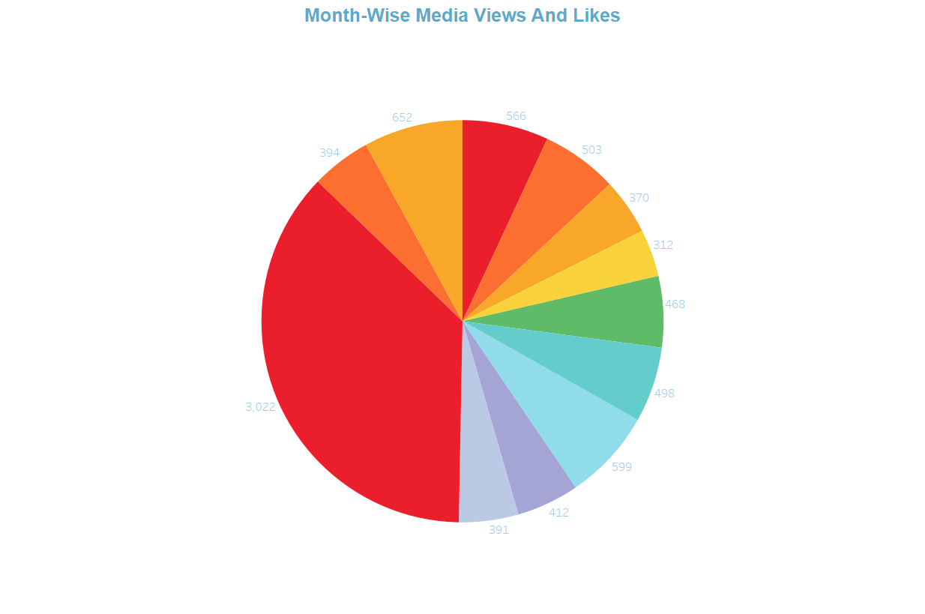

Activity 2 : **Day-Wise Engagement Ratio**

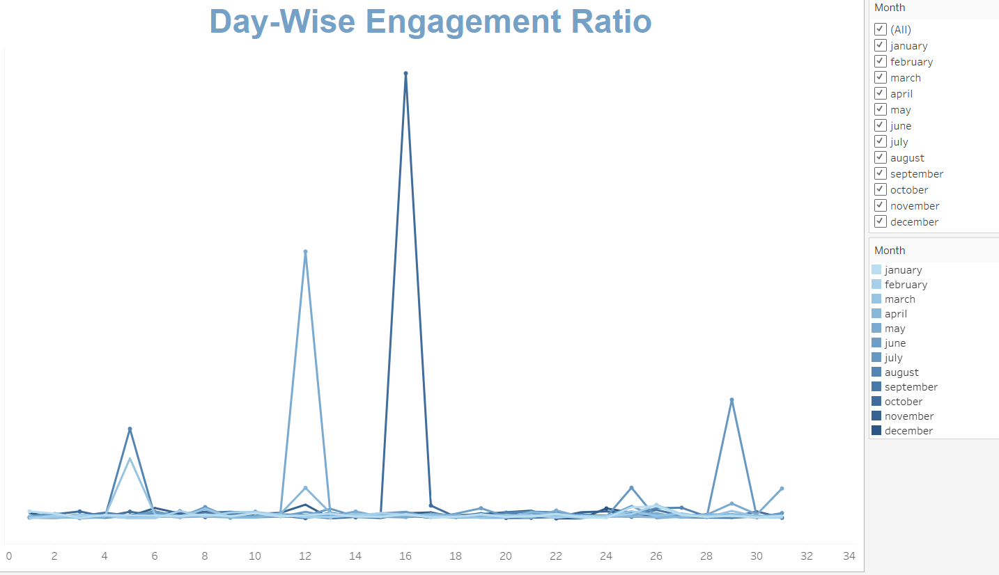

Activity 3 : **Total Impressions, Media Views, And Likes**

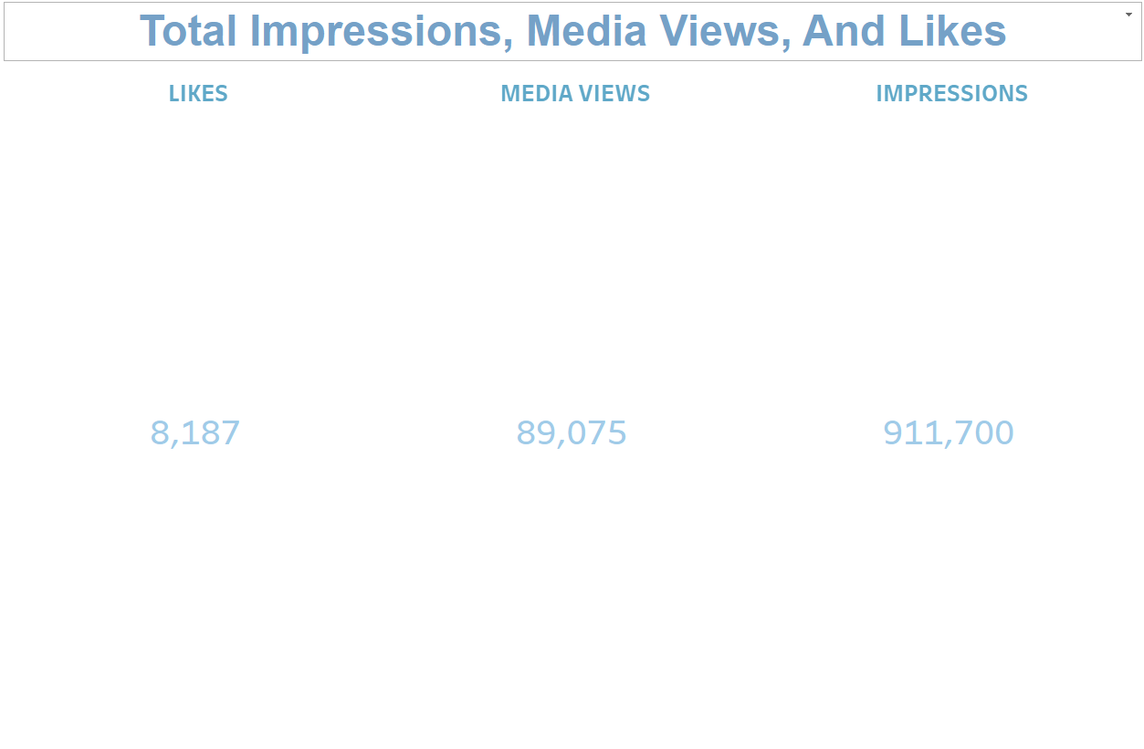

Activity 4 : **TOP 10 DAYS OF MEDIA VIEWS**

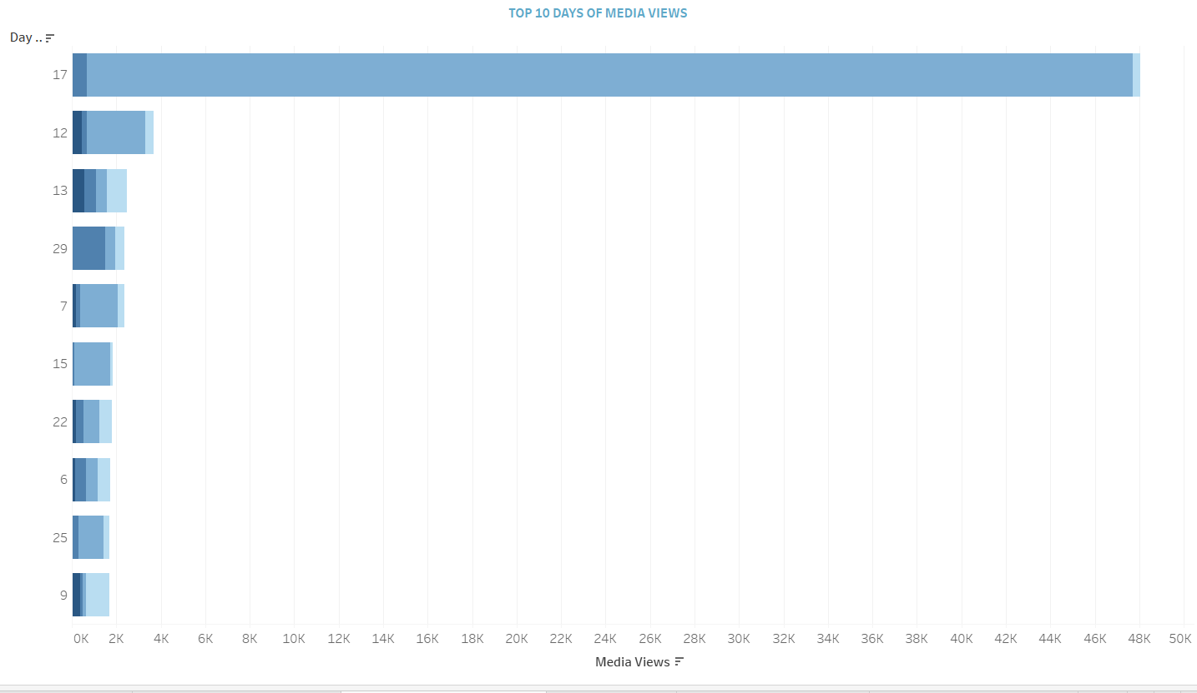

Activity 5: **DAY-WISE REPLIES**

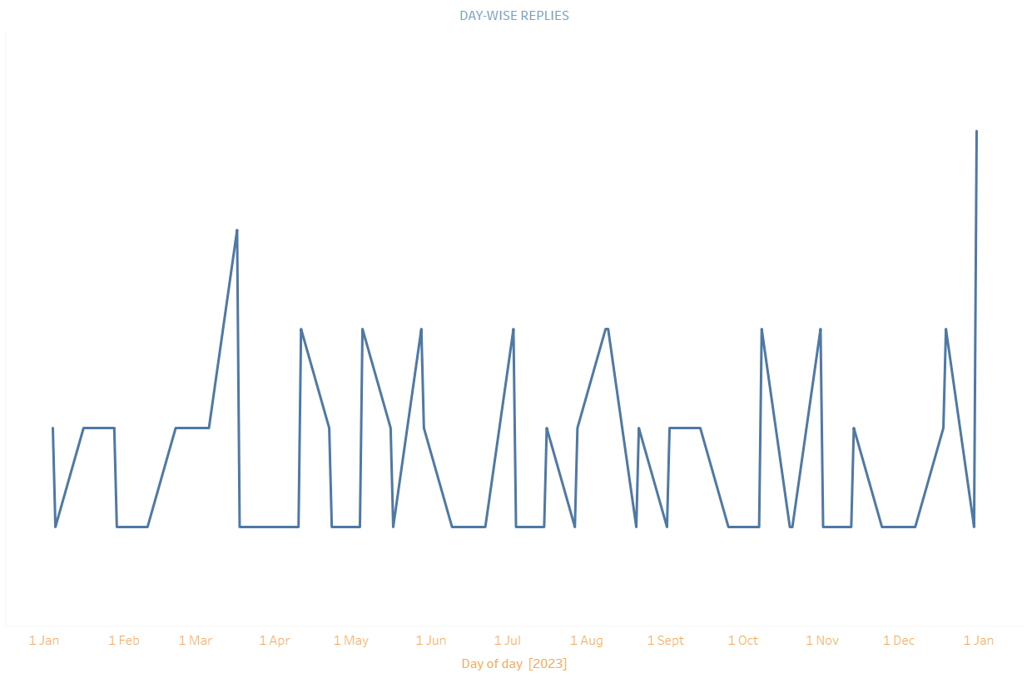

Activity 6 : **TOP 10 DAYS IMPRESSIONS**

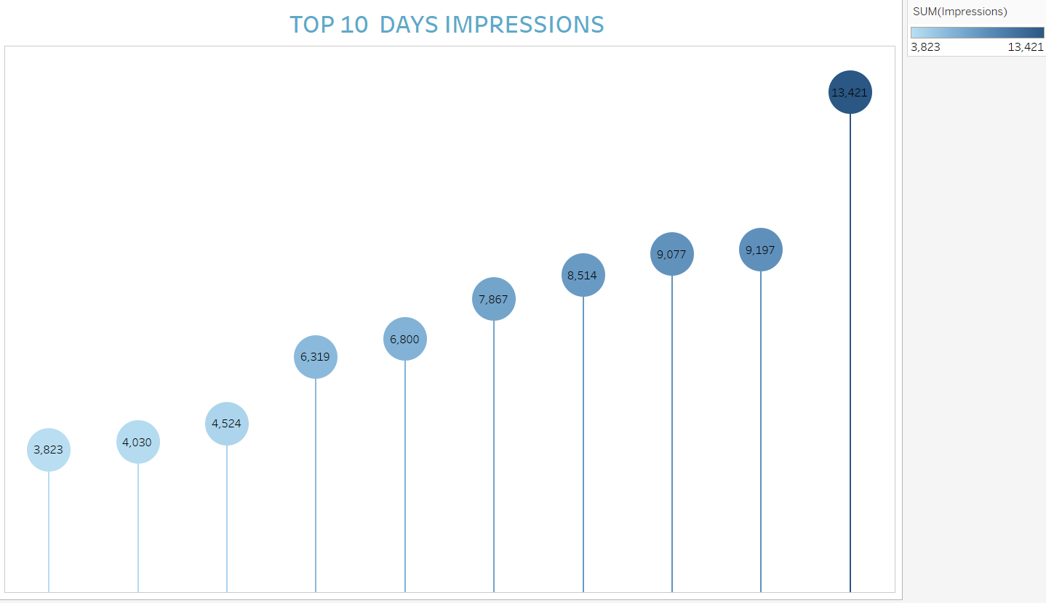

Activity 7 : **DAY-WISE MEDIA VIEWS AND LIKES**

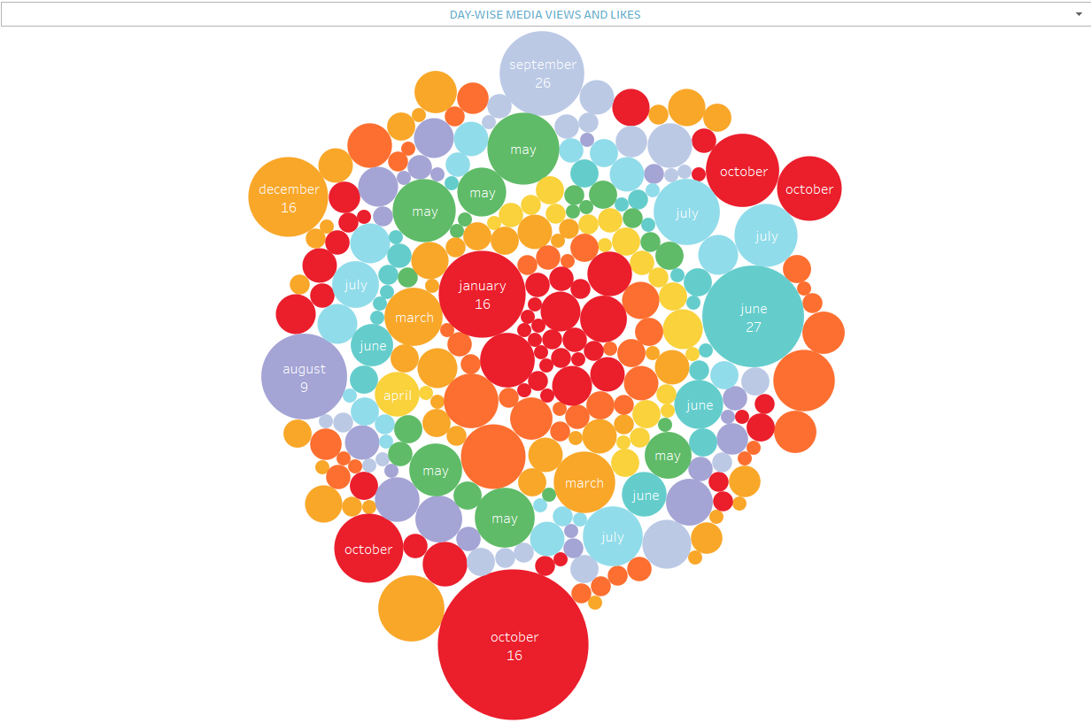

Activity 8 : **DAY-WISE RETWEETS AND IMPRESSIONS**

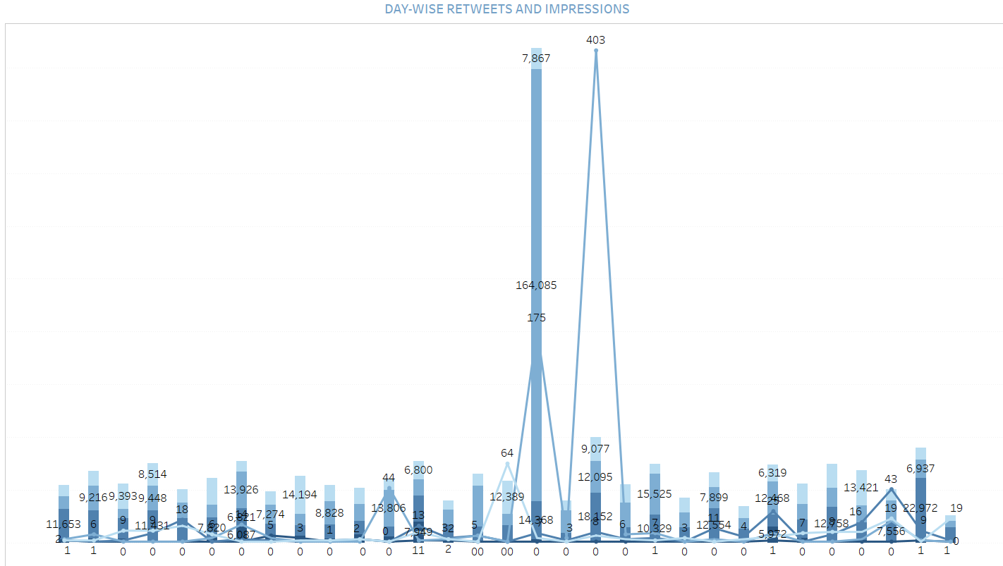

**Milestone 4: Dashboard**

In simple words dashboard means that, adding the all the visualizations in the single dashboard sheet and by adding the kpi, using kpi’s we can make custom filters to it and by adding all visualizations on one sheet,we can manage all the data and we can understand easily . Using pictures and numbers, helping you keep track of data

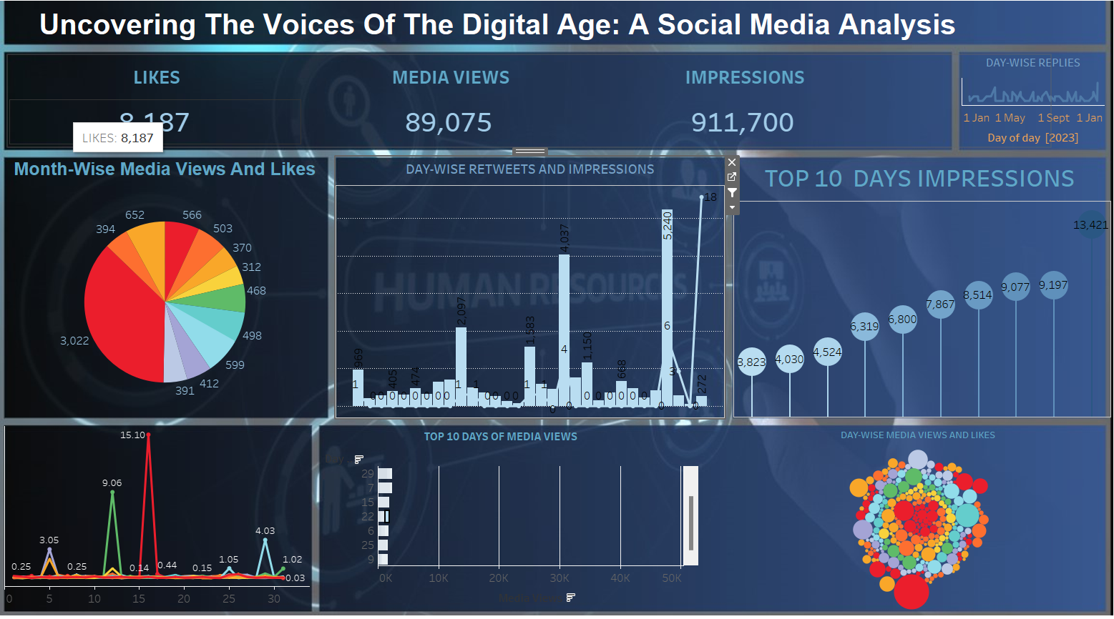

**Milestone 5: Story**

We can make stories with my data by creating colorful charts and graphs . In the story we can create the story points and we can create colour in the differcence in story , and with the story we can tell other that we can explain the visualization deeply and interestingly

**Activity 1: No of Scenes of Story**

**story**

**Story**

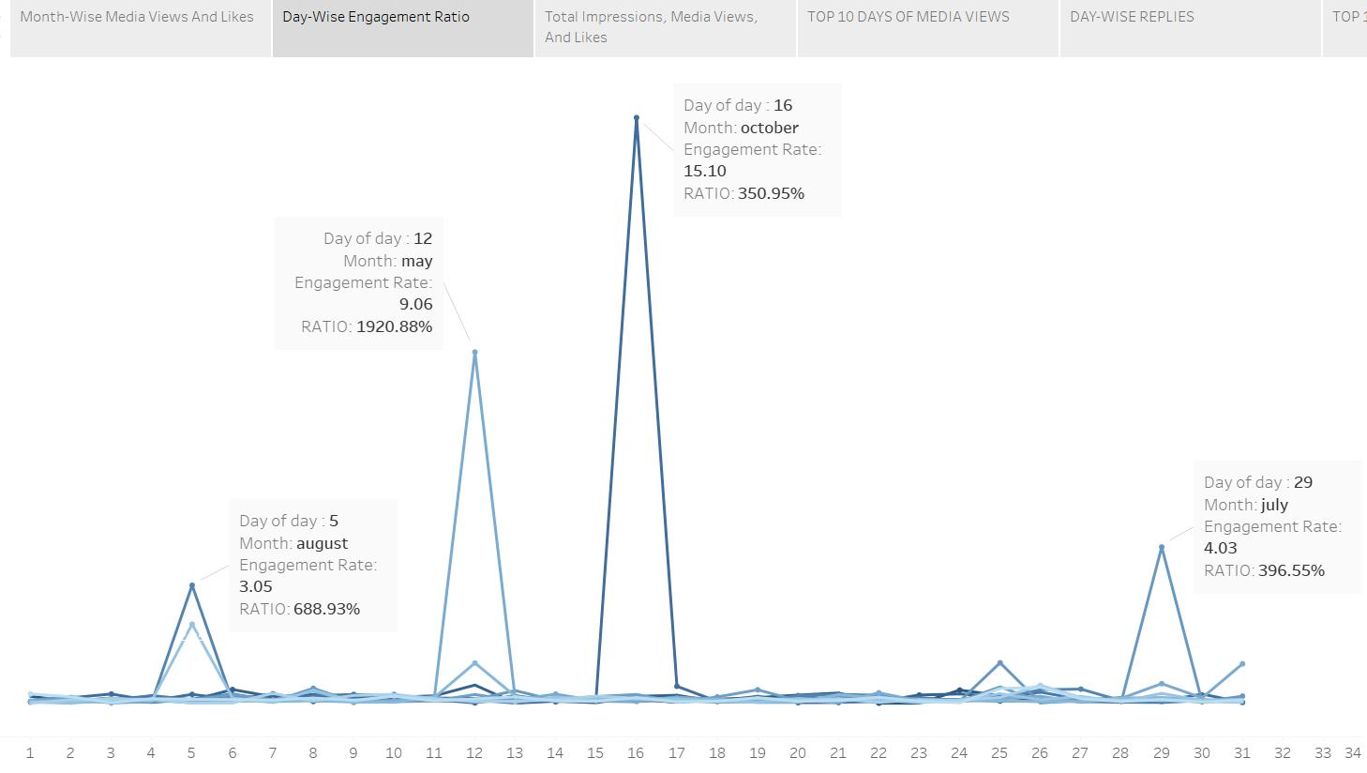

**Story**

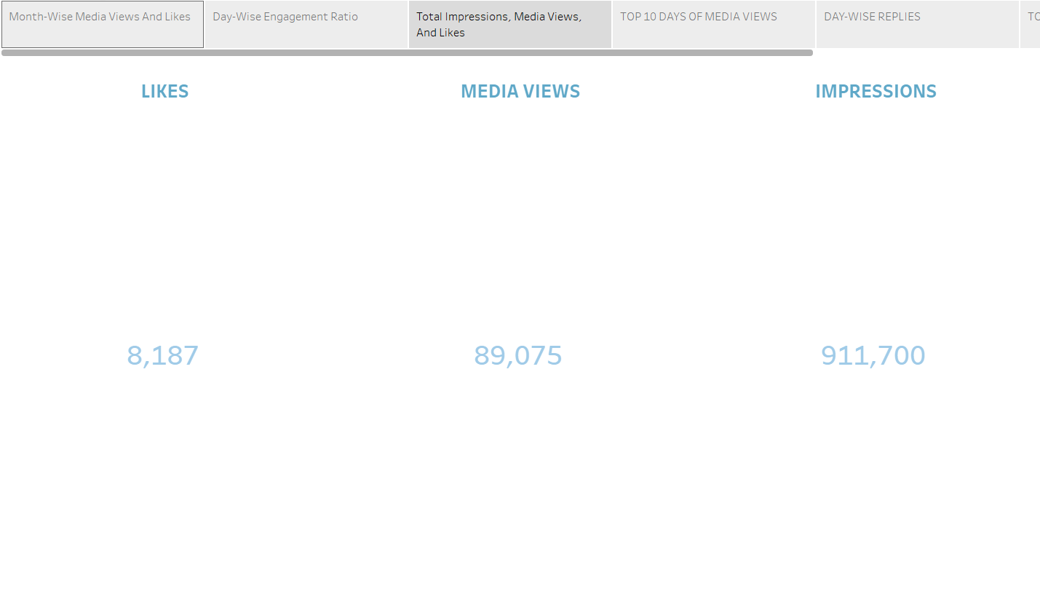

**Story**

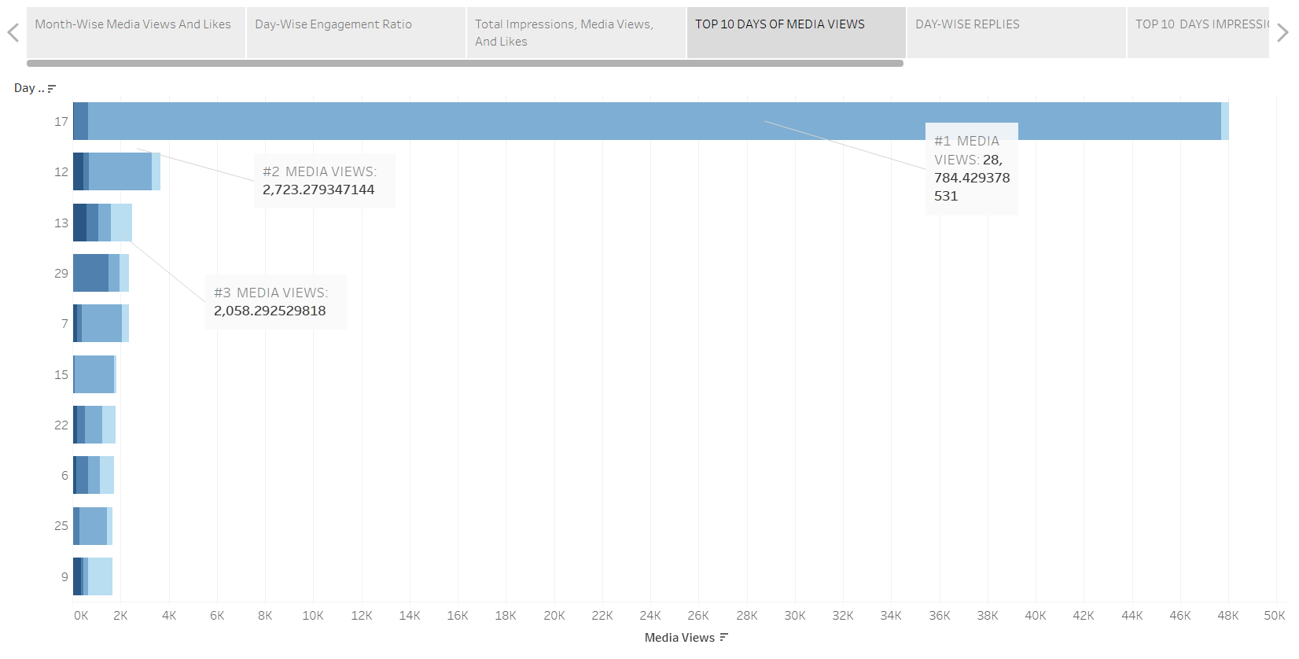

**Story**



**Story**

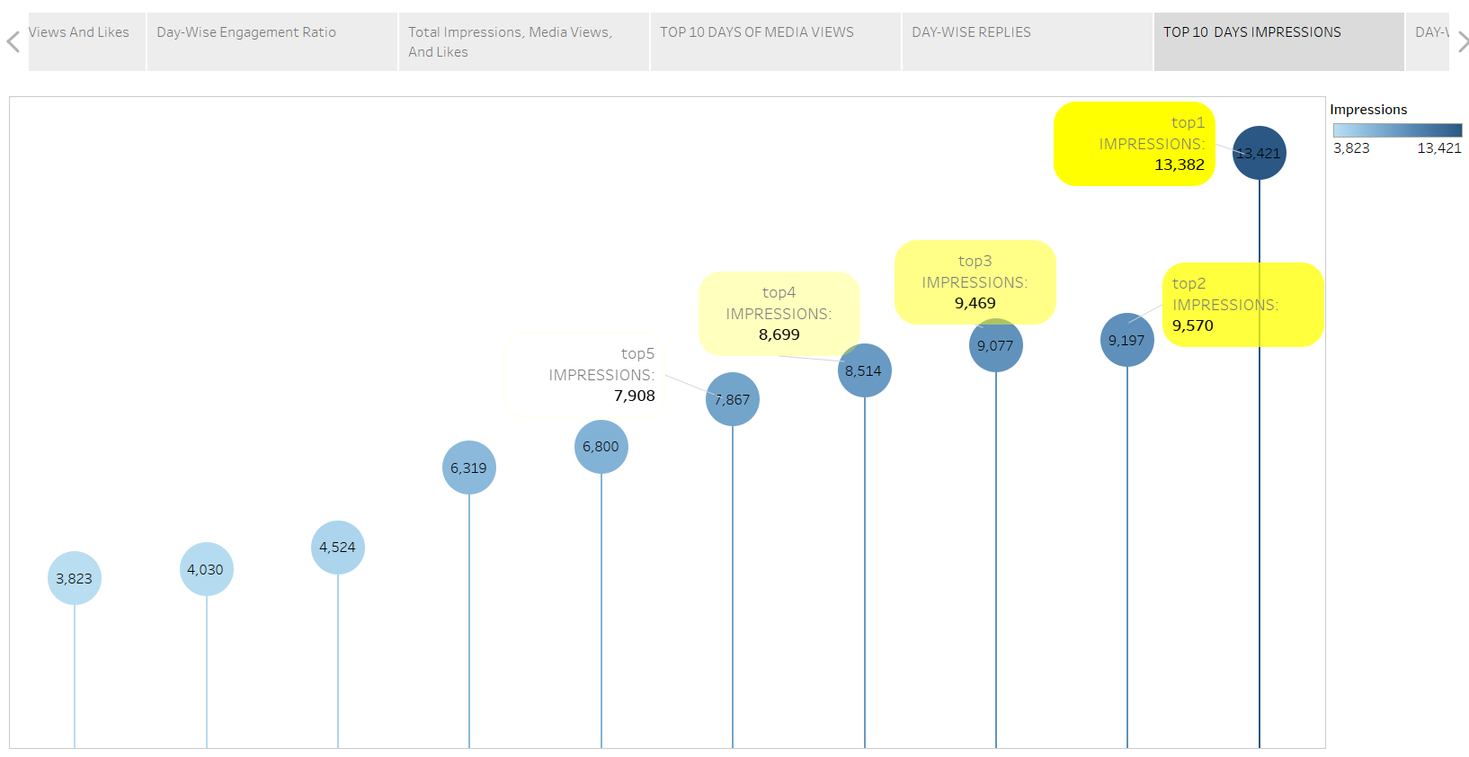

**Story**

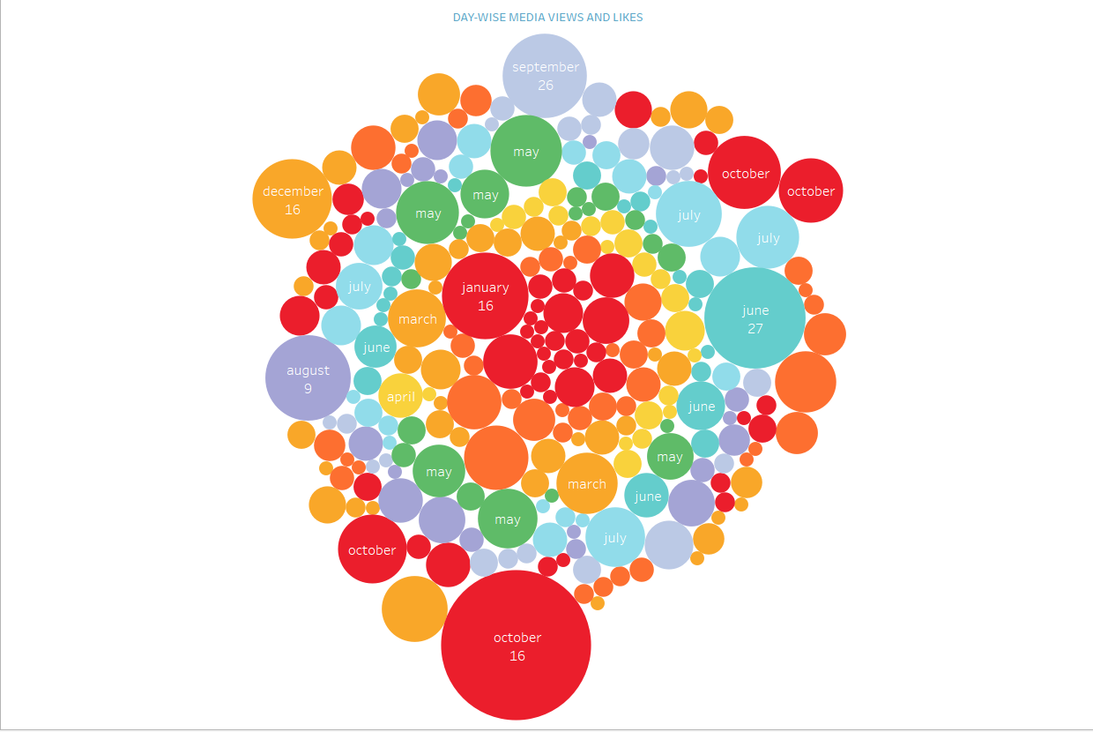

**Story**

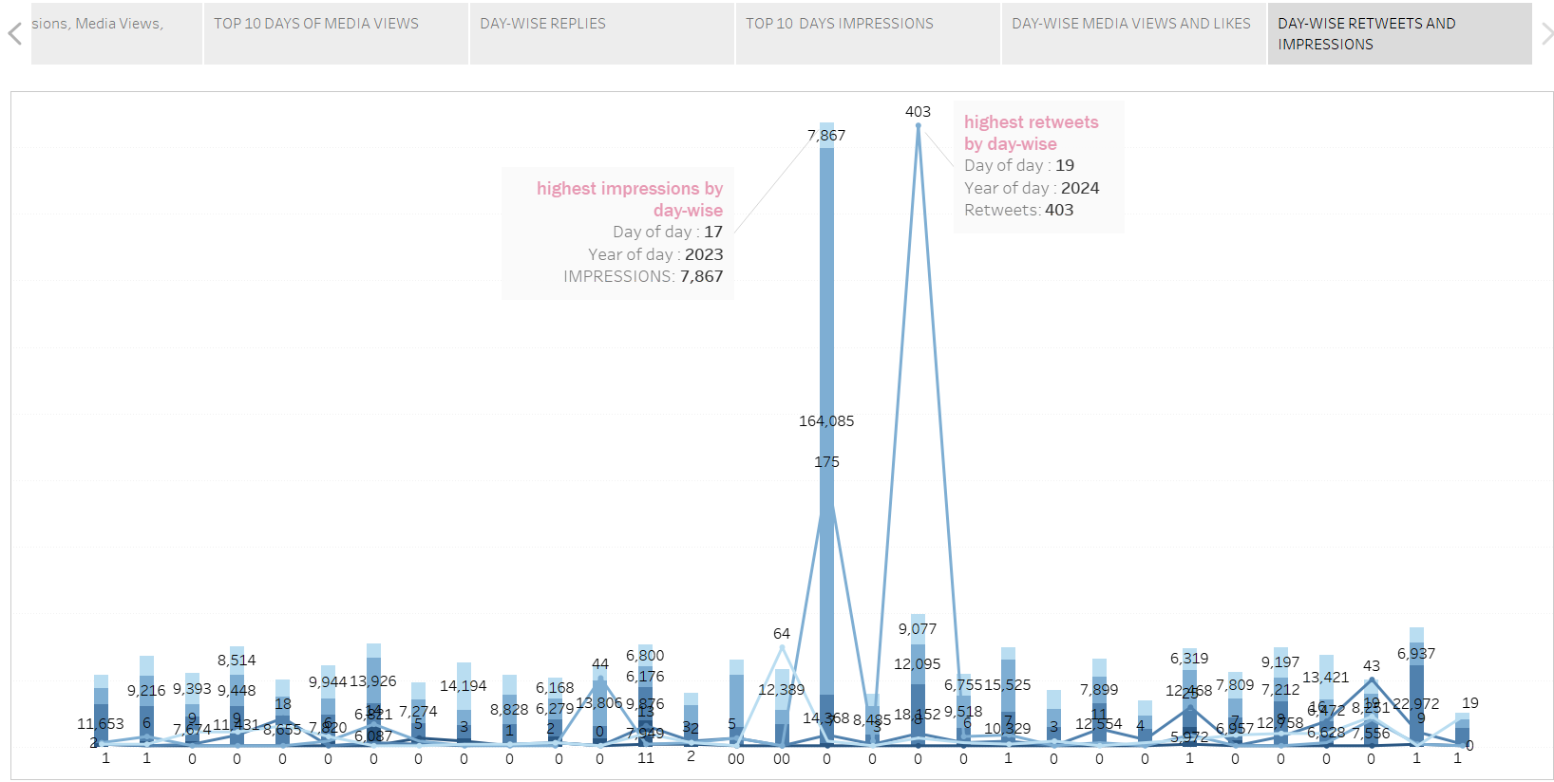

**Milestone 6: Performance Testing**

Activity 1: **Amount of Data Loaded**

By adding the data in the datasource we can see the data in the fields section and we can add the extra data and connect with it, by the sets,union,sub-union etc and I can change the data or extract the data in the live or extract and we can add more filters to it also.

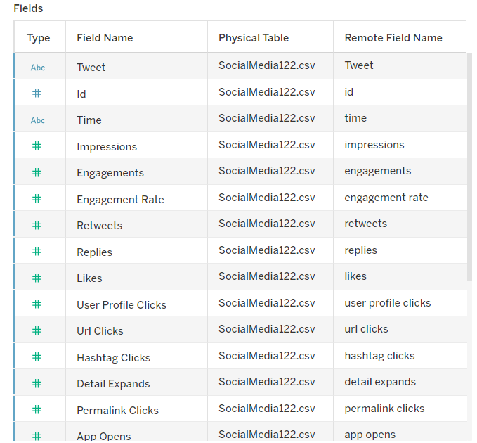

**Activity 2: Utilization of Data Filters**

By using the data filters we can see the specific data in the entire dashboard and Data filters help you see only the specific information you need by letting you pick and choose what data to display.

Activity 2.1: **Selected “february” as a Filter**

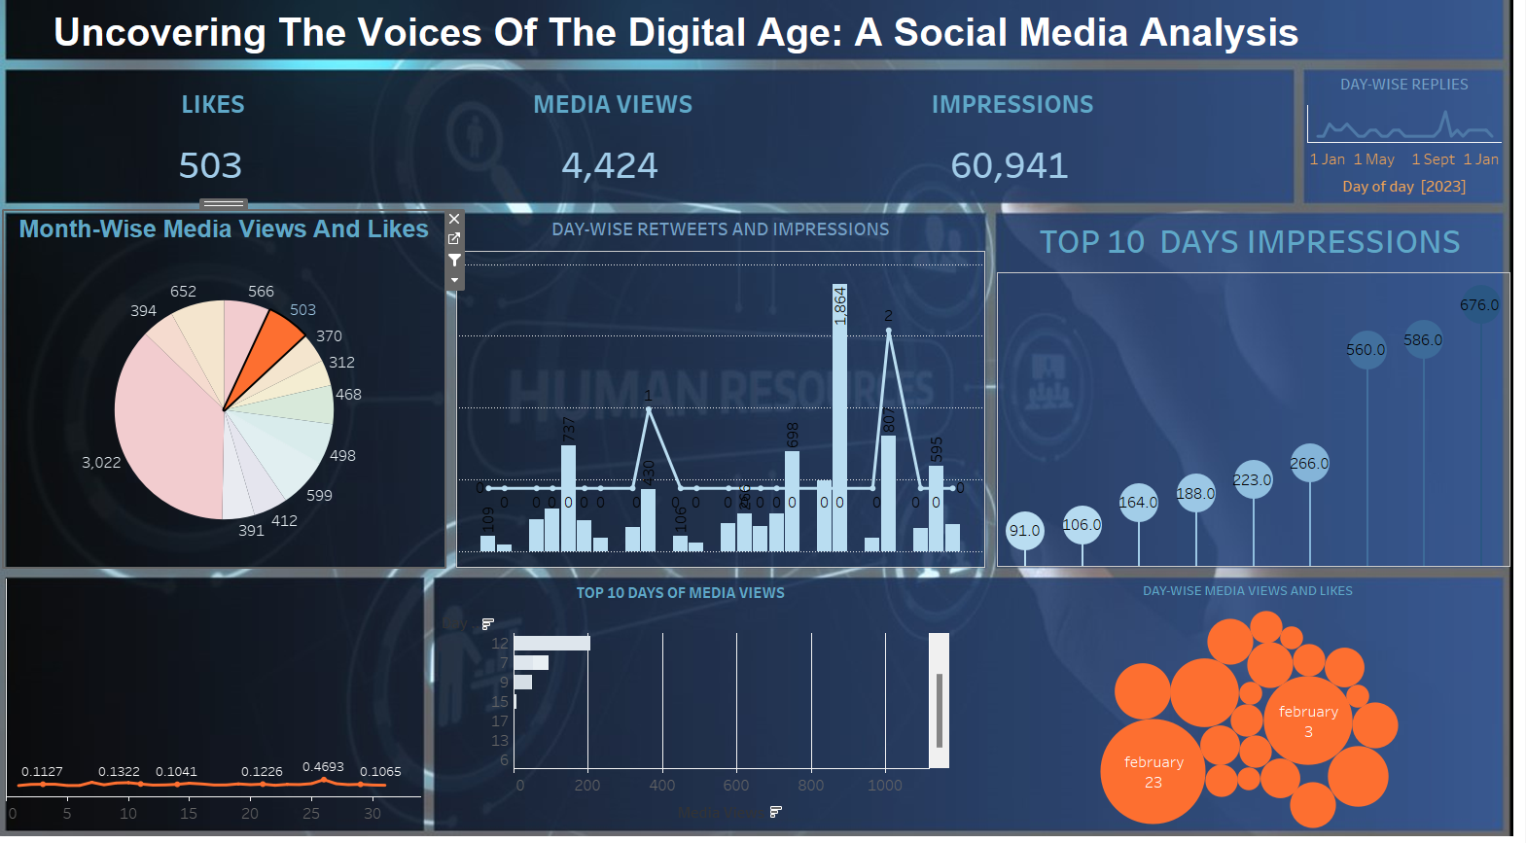

Activity 2.1: Selected “october” as a Filter

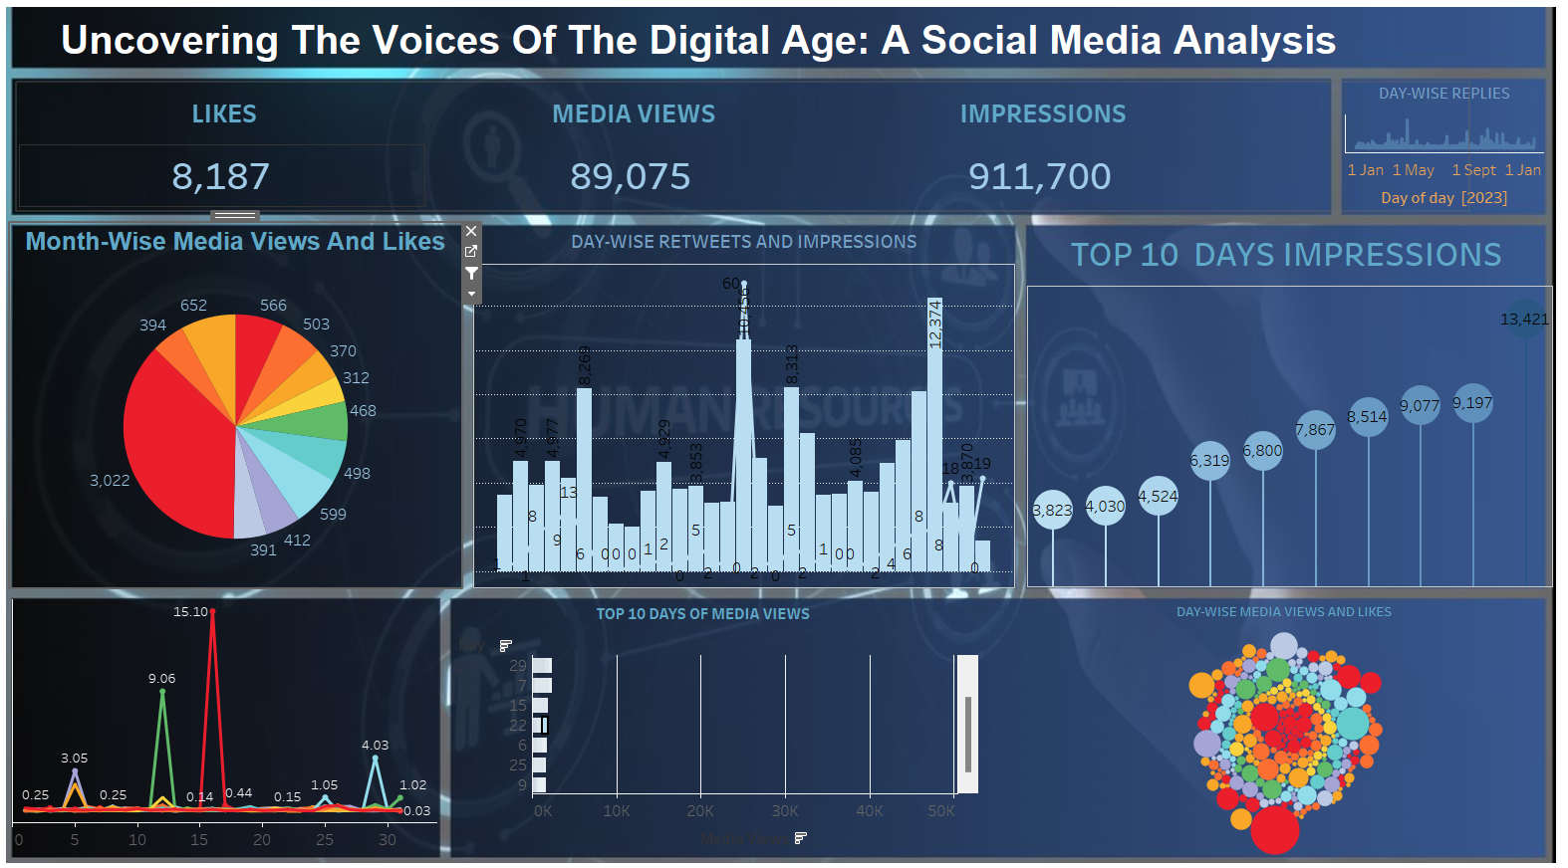

**Activity 3: No of Calculation Fields**

**Activity 3.1: Set**

We are adding numbers or average, we can perform these maths operations or create new values based on existing ones to create new data.

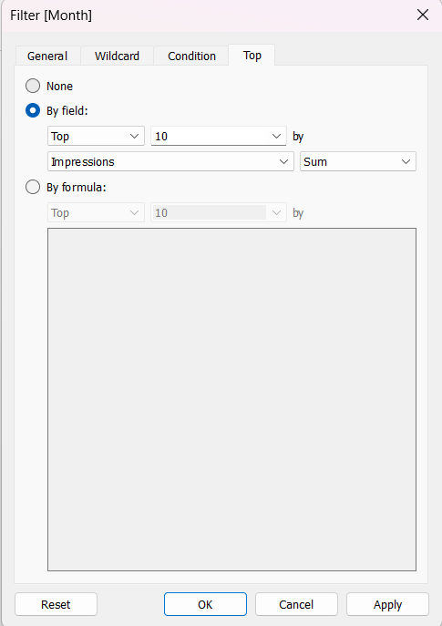

**Activity 4: No of Visualizations/ Graphs**

### 1. Month-Wise Media Views And Likes

### 2. Day-Wise Engagement Ratio

### 3. Total Impressions, Media Views, And Likes

### 4. Top 10 Days Of Media Views

### 5. Day-Wise Replies

### 6. Top 10 Days Impressions

### 7. Day-Wise Media Views And Likes

### 8. Day-Wise Retweets And Impressions

### Milestone 7: Web integration

### Web integration is like connecting different websites together so they can work together smoothly. It's like having one website talk to another to share information or perform actions, making the internet experience more seamless and convenient for users.

### Publishing dashboard and reports to tableau public

### Step 1: Go to Dashboard/story, click on share button on the top ribbon

### 

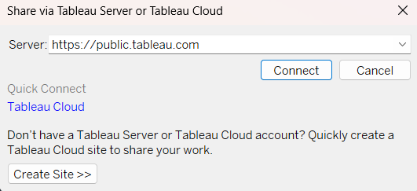

Give the server address of your tableau public account and click on connect

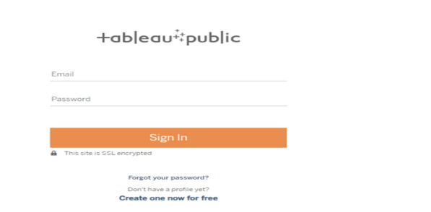

Once you login into your tableau public using the credentials, the particular visualization will be published into tableau public

**Note: While publishing the visualization to the public, the respective sheet will get published when you click on share option.**

Activity 1: **Dashboard and Story embed with UI With Flask**

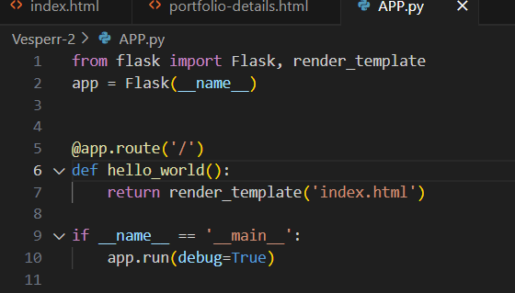

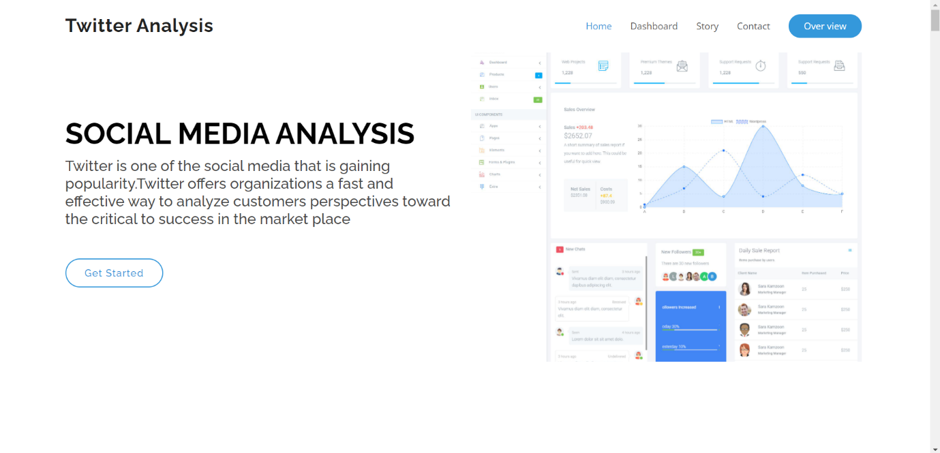

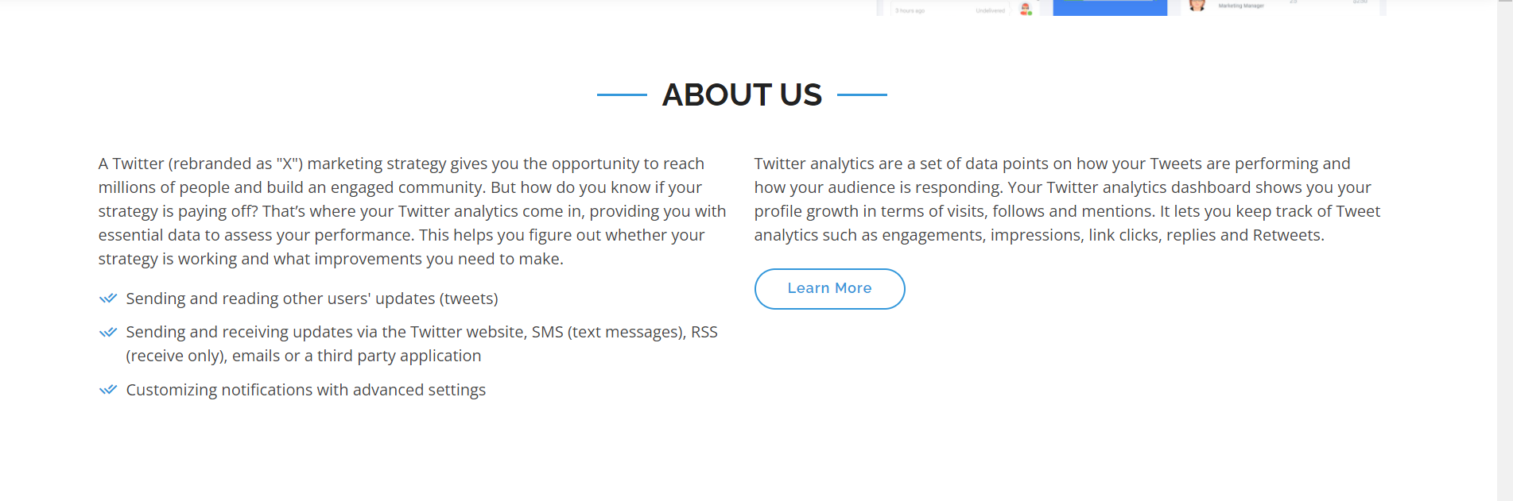

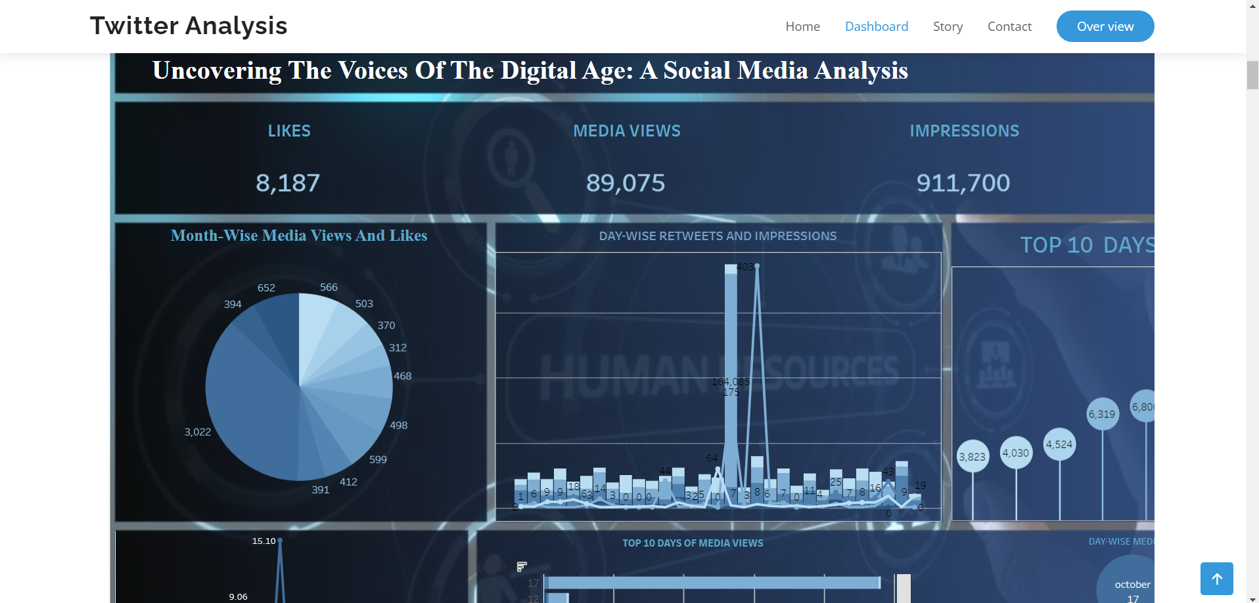

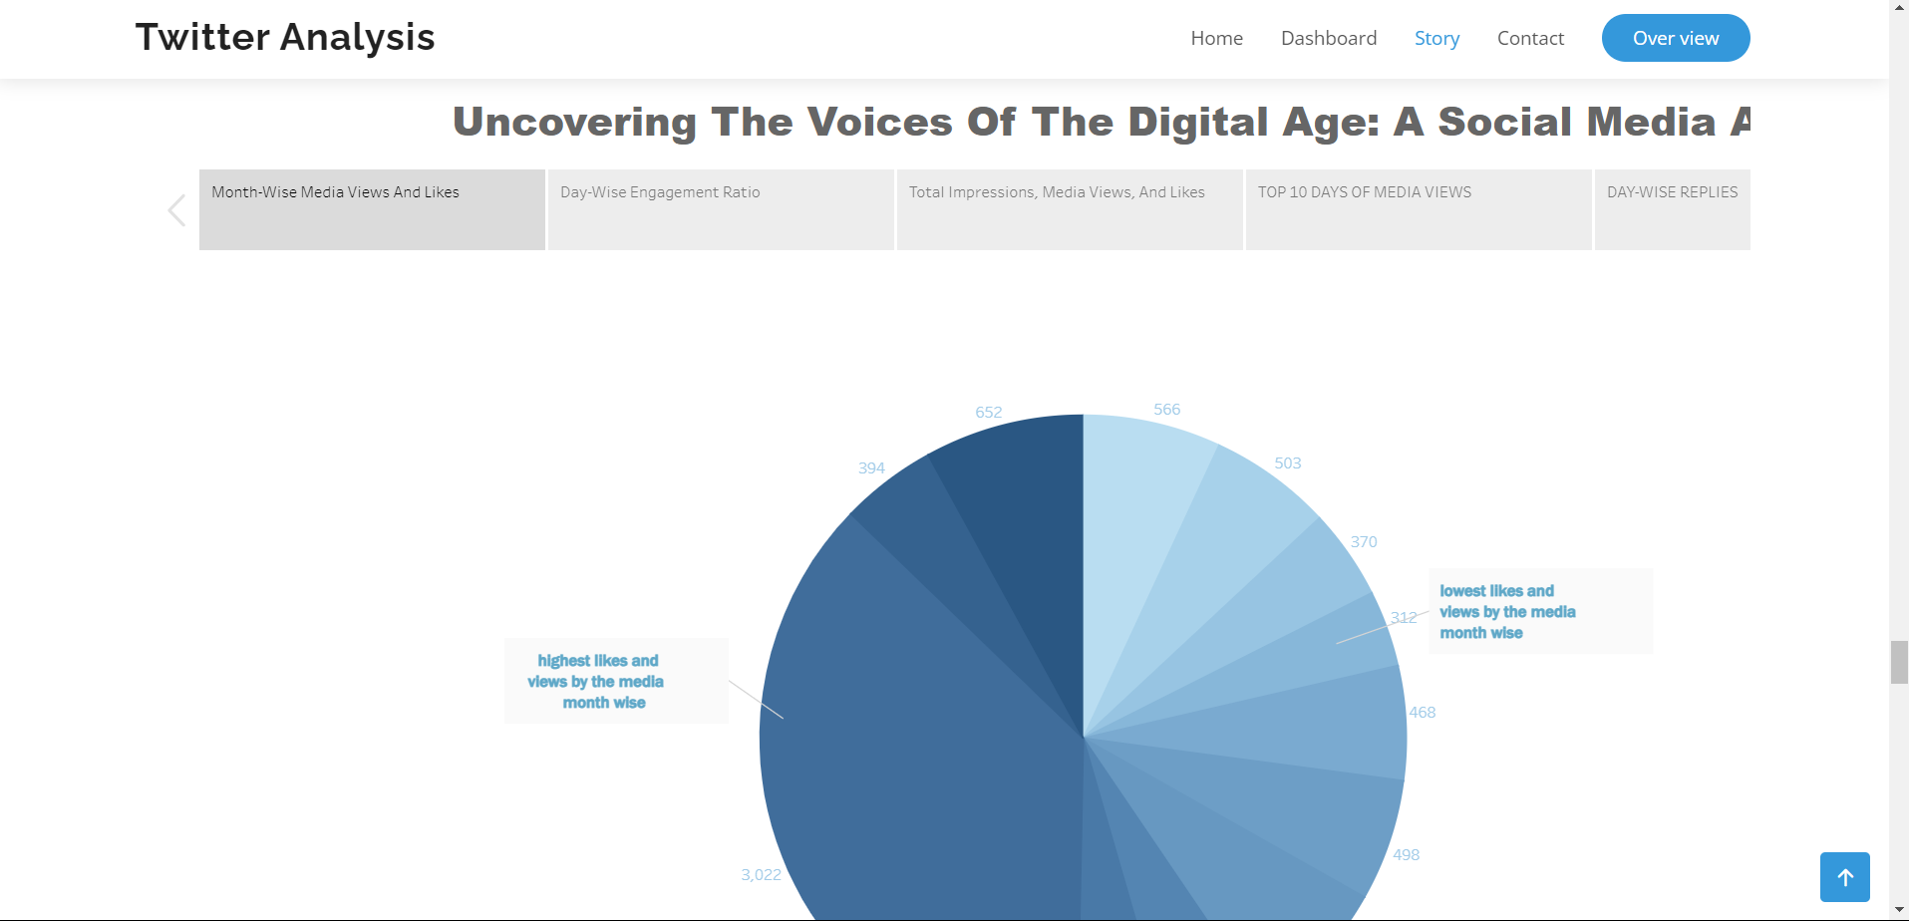

Milestone 8: **Project Demonstration & Documentation Below mentioned deliverables to be submitted along with other deliverables**

Activity 1:- Record explanation Video for project end to end solution

Activity 2:- Project Documentation-Step by step project development procedure